**SQL tables**

## Database SQL Tables

CREATE TABLE Customer (

cus_ID INT AUTO_INCREMENT NOT NULL,

cus_name VARCHAR(50) NOT NULL,

cus_phone_N VARCHAR(20) NOT NULL,

cus_address VARCHAR(50) NOT NULL,

cus_Pizza_name VARCHAR(50) NOT NULL,

cus_lastOrder_date DATE NOT NULL,

PRIMARY KEY (cus_ID)

);

CREATE TABLE Orders (

order_ID INT NOT NULL,

cus_ID INT NOT NULL,

order_address VARCHAR(50) NOT NULL,

order_phone_N VARCHAR(20) NOT NULL,

order_Date DATE NOT NULL,

Total DECIMAL(15, 2) NOT NULL,

Tax DECIMAL(10, 2) NOT NULL,

delivery_Cost DECIMAL(20, 2) NOT NULL,

driver_ID INT NOT NULL,

PRIMARY KEY (order_ID),

FOREIGN KEY (cus_ID) REFERENCES Customer(cus_ID)

);

CREATE TABLE Cook (

cook_ID INT NOT NULL,

order_ID INT NOT NULL,

cook_name VARCHAR(50) NOT NULL,

cook_specialty VARCHAR(50) NOT NULL,

PRIMARY KEY (cook_ID),

FOREIGN KEY (order_ID) REFERENCES Orders(order_ID)

);

CREATE TABLE Food (

food_ID INT NOT NULL,

cook_ID INT NOT NULL,

food_name VARCHAR (50) NOT NULL,

food_ingr VARCHAR (100) NOT NULL,

food_price DECIMAL(15,2) NOT NULL,

PRIMARY KEY (food_ID),

FOREIGN KEY (cook_ID) REFERENCES Cook(cook_ID)

);

CREATE TABLE Delivery (

driver_ID INT NOT NULL,

driver_name VARCHAR(50) NOT NULL,

delivery_date DATE NOT NULL,

receipt_ID INT NOT NULL,

coupon_ID INT,

order_id INT NOT NULL,

food_ID INT NOT NULL,

payment DECIMAL(10, 2) NOT NULL,

PRIMARY KEY (driver_ID),

FOREIGN KEY (order_ID) REFERENCES orders (order_ID),

FOREIGN KEY (food_ID) REFERENCES Food(food_ID)

);

CREATE TABLE Management (

manager_ID INT,

manager_name VARCHAR(50),

weekly_total DECIMAL(10,2),

driver_ID INT NOT NULL,

PRIMARY KEY (manager_ID),

FOREIGN KEY (driver_ID) REFERENCES Delivery(driver_ID)

);

CREATE TABLE PPS(

PPS_ID INT NOT NULL,

cus_ID INT NOT NULL,

order_ID INT NOT NULL,

cook_ID INT NOT NULL,

food_ID INT NOT NULL,

driver_ID INT NOT NULL,

manager_ID INT NOT NULL,

PRIMARY KEY (PPS_ID),

FOREIGN KEY (cus_ID) REFERENCES Customer(cus_ID),

FOREIGN KEY (order_ID) REFERENCES Orders(order_ID),

FOREIGN KEY (cook_ID) REFERENCES Cook(cook_ID),

FOREIGN KEY (food_ID) REFERENCES Food(food_ID),

FOREIGN KEY (driver_ID) REFERENCES Delivery (driver_ID),

FOREIGN KEY (manager_ID) REFERENCES Management (manager_ID)

);

### **Trigger**

DELIMITER $$

CREATE TRIGGER Customer_Order_Trigger

BEFORE INSERT ON Orders

FOR EACH ROW

BEGIN

IF NEW.cus_ID IS NULL THEN

INSERT INTO Customer (cus_address, cus_phone_N, cus_lastOrder_date)

VALUES (NEW.order_address, NEW.order_phone_N, NEW.order_Date);

SET NEW.cus_ID = LAST_INSERT_ID();

END IF;

END$$

DELIMITER ;

### **Trigger test Demo**

**Insert Code**

INSERT INTO Customer (cus_ID, cus_name, cus_phone_N, cus_address, cus_Pizza_name, cus_lastOrder_date)

VALUES

(NULL, "Pamela Love ", "205-765-0045", "864 Fox st, Cherry MD","Cheese Pizza", "2023-03-31");

**Table Before**

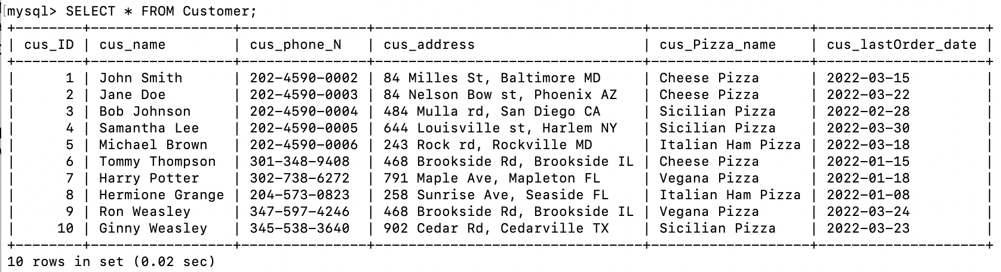

**Table After Trigger**

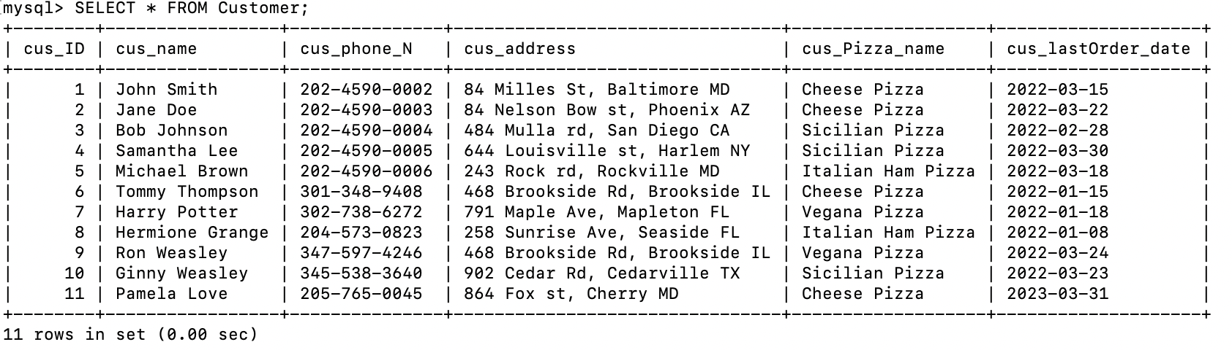

## Populating table

### Customer table

|  |  |  |  |  |  |
| --- | --- | --- | --- | --- | --- |
| **cus_ID** | **cus_name** | **cus_phone_N** | **cus_address** | **cus_Pizza_name** | **cus_lastOrder_date** |
| **1** | John Smith | 202-4590-0002 | 84 Milles St, Baltimore MD | Cheese Pizza | 2022-03-15 |
| **2** | Jane Doe | 202-4590-0003 | 84 Nelson Bow st, Phoenix AZ | Cheese Pizza | 2022-03-22 |
| **3** | Bob Johnson | 202-4590-0004 | 484 Mulla rd, San Diego CA | Sicilian Pizza | 2022-02-28 |
| **4** | Samantha Lee | 202-4590-0005 | 644 Louisville st, Harlem NY | Sicilian Pizza | 2022-03-30 |
| **5** | Michael Brown | 202-4590-0006 | 243 Rock rd, Rockville MD | Italian Ham Pizza | 2022-03-18 |
| **6** | Tommy Thompson | 301-348-9408 | 468 Brookside Rd, Brookside IL | Cheese Pizza | 2022-01-15 |
| **7** | Harry Potter | 302-738-6272 | 791 Maple Ave, Mapleton FL | Vegana Pizza | 2022-01-18 |
| **8** | Hermione Grange | 204-573-0823 | 258 Sunrise Ave, Seaside FL | Italian Ham Pizza | 2022-01-08 |
| **9** | Ron Weasley | 347-597-4246 | 468 Brookside Rd, Brookside IL | Vegana Pizza | 2022-03-24 |
| **10** | Ginny Weasley | 345-538-3640 | 902 Cedar Rd, Cedarville TX | Sicilian Pizza | 2022-03-23 |

### Orders table

|  |  |  |  |  |  |  |  |  |
| --- | --- | --- | --- | --- | --- | --- | --- | --- |
| **order_ID** | **cus_ID** | **order_address** | **order_phone_N** | **order_Date** | **Total** | **Tax** | **delivery_Cost** | **driver_ID** |
| **1** | 3 | 484 Mulla rd, San Diego CA | 202-4590-0004 | 2022-02-28 | 50.00 | 3.50 | 5.00 | 2 |
| **2** | 6 | 468 Brookside Rd, Brookside IL | 301-348-9408 | 2022-01-15 | 200.00 | 14.00 | 12.00 | 6 |
| **3** | 1 | 84 Milles St, Baltimore MD | 202-4590-0002 | 2022-03-15 | 30.00 | 7.00 | 8.00 | 1 |
| **4** | 2 | 84 Nelson Bow st, Phoenix AZ | 202-4590-0003 | 2022-03-22 | 25.00 | 3.75 | 3.00 | 3 |
| **5** | 9 | 468 Brookside Rd, Brookside IL | 347-597-4246 | 2022-03-24 | 15.00 | 5.50 | 9.00 | 5 |
| **6** | 8 | 258 Sunrise Ave, Seaside FL | 204-573-0823 | 2022-01-15 | 20.00 | 4.00 | 12.00 | 6 |
| **7** | 5 | 243 Rock rd, Rockville MD | 202-4590-0006 | 2022-03-18 | 25.00 | 8.75 | 10.00 | 2 |
| **8** | 4 | 644 Louisville st, Harlem NY | 202-4590-0005 | 2022-03-30 | 30.00 | 3.50 | 5.00 | 1 |
| **9** | 7 | 791 Maple Ave, Mapleton FL | 302-738-6272 | 2022-01-18 | 35.00 | 5.25 | 6.00 | 4 |
| **10** | 2 | 902 Cedar Rd, Cedarville TX | 345-538-3640 | 2022-03-23 | 15.00 | 7.00 | 8.00 | 3 |

### cook table

|  |  |  |  |
| --- | --- | --- | --- |
| **cook_ID** | **order_ID** | **cook_name** | **cook_specialty** |
| **1** | 1 | John Smith | Italian Pizza |
| **2** | 2 | Maria Rodriguez | Mexican Pizza Style |
| **3** | 3 | David Lee | Italian Pizza |
| **4** | 4 | Fatima Khan | Mexican Pizza Style |
| **5** | 5 | Alexandre Dupont | French Pizza |
| **6** | 6 | Marta Silva | Italian Pizza |
| **7** | 7 | Andrea Rossi | New York Pizza Style |
| **8** | 8 | Oliver Schmidt | Spanish Pizza Style |
| **9** | 9 | Aisha Ahmed | Mediterian Pizza Style |
| **10** | 10 | Javier Hernandez | Spanish Pizza Style |

### 

### Food table

|  |  |  |  |  |
| --- | --- | --- | --- | --- |
| **food_ID** | **cook_ID** | **food_name** | **food_ingr** | **food_price** |
| **1** | 1 | Cheese Pizza | Dough, tomato sauce, mozzarella cheese | 10.99 |
| **2** | 2 | Sicilian Pizza | Dough, tomato sauce, parmesan cheese, oregano | 12.99 |
| **3** | 3 | Italian Ham Pizza | Dough, tomato sauce, ham, mozzarella cheese, parmesan cheese | 14.99 |
| **4** | 4 | Vegana Pizza | Dough, tomato sauce, mushrooms, green peppers, onions, olives, artichokes | 15.99 |

### Delivery table

|  |  |  |  |  |  |  |  |
| --- | --- | --- | --- | --- | --- | --- | --- |
| **driver_ID** | **driver_name** | **delivery_date** | **receipt_ID** | **coupon_ID** | **order_id** | **food_ID** | **payment** |
| **1** | John Smith | 2023-03-28 | 12345 | NULL | 1 | 1 | 20.99 |
| **2** | Emily Jones | 2023-03-29 | 12346 | NULL | 2 | 1 | 15.99 |
| **3** | Mark Thompson | 2023-03-30 | 12347 | 123 | 3 | 2 | 30.25 |
| **4** | Samantha Davis | 2023-03-31 | 12348 | 124 | 4 | 2 | 18.00 |
| **5** | David Rodriguez | 2023-04-01 | 12349 | 125 | 5 | 3 | 20.00 |
| **6** | Karen Lee | 2023-04-02 | 12350 | NULL | 6 | 3 | 14.30 |
| **7** | Juan Hernandez | 2023-04-03 | 12351 | 127 | 7 | 4 | 23.94 |
| **8** | Jessica Nguyen | 2023-04-04 | 12352 | NULL | 8 | 4 | 17.99 |
| **9** | William Kim | 2023-04-05 | 12353 | 129 | 9 | 1 | 38.74 |
| **10** | Linda Wilson | 2023-04-06 | 12354 | 789 | 10 | 2 | 14.68 |

### Management table

|  |  |  |  |
| --- | --- | --- | --- |
| **manager_ID** | **manager_name** | **weekly_total** | **driver_ID** |
| **1** | John Smith | 1250.50 | 1 |
| **2** | Jane Doe | 1100.75 | 2 |
| **3** | Mike Johnson | 975.25 | 3 |
| **4** | Sarah Lee | 1850.00 | 4 |
| **5** | David Kim | 1200.00 | 5 |